
Recovery of carbon from rice straw for simultaneous production of protein, lipid and carbohydate by Scenedesmus sp. via mixotrophic cultivation
Do Thi Cam Van^{1, *}, Pham Thi Mai Huong²
¹HaUI Institute of Technology, Ha Noi University of Industry, 298 Cau Dien, Bac Tu Liem, Ha Noi, Viet Nam
²Faculty of Chemical Technology, Ha Noi University of Industry, 298 Cau Dien, Bac Tu Liem, Ha Noi, Viet Nam
*Emails: 1.docamvan85@gmail.com, 2.docamvan85@haui.edu.vn
Received: 23 August 2023; Accepted for publication: 24 April 2024

Abstract. Rice straw is abundantly generated as a by-product of agriculture in Viet Nam. However, the material mainly contains hemicellulose and cellulose, which can be hydrolyzed to reducing sugars as a carbon source for the mixotrophic production of protein-rich microalgae biomass. In this study, rice straw was obtained from local farmers and transformed to hydrolysate via separated alkaline or acid and sequential alkaline-acid treatments to evaluate sugar conversion efficiency. The hydrolysate then was used as a carbon source for the cultivation of Scenedesmus sp. via mixotrophic mode. Data revealed that pretreatment with H₂SO₄, NaOH, and combined NaOH + H₂SO₄ yielded sugar conversion of 12 – 13 %, 11 – 12 % and 22 %, respectively. Scenedesmus sp. displayed a good growth performance in both rice straw hydrolysates with and without supplement of nitrogen and phosphorous, reaching the maximal optical density of 1.5 Abs in the culture medium of BG-11 with 10 – 50 % v/v hydrolysate. The sugar utilization efficiency by Scenedesmus sp. was determined as 70 – 94 %. The Scenedesmus sp. was assayed to be rich in protein with its content of up to 45 % based on a dry basis. The Scenedesmus sp. biomass is a potential protein source for animal and aquafeed formulation. Our preliminary results demonstrated that recovery of carbon from such agricultural by-products for protein-rich material for novel food development in animal food and aquafeed industries is promising.
Keywords: Biomass production, Carbon, protein, rice straw hydrolysate, Scenedesmus sp.
Classification numbers: 1.4.4, 1.4.3, 3.1.1
1. Introduction
Rice straw is greatly generated as a popular agricultural byproduct in Viet Nam. According to a recent study published in 2017, Viet Nam produced approximately 70.7 million dry tons of rice straw [1]. Rice straw in Viet Nam is a huge renewable resource, which is promising for application in many fields. In the past, rice straw was mainly used for burning, roofing, and feeding livestock (e.g., cow, horse, and buffalo). According to the International Rice Research Institute (IRRI) there were about 20 million tons of rice straw burned in Viet Nam per year accounting for 60 % of the total volume which not only wasted natural resources, but also caused environmental pollution due to the emission of greenhouse gases (e.g., CO₂, CO, CH₄, SO₂, NO₂) [2]. Moreover, rice smoke is spicy, causing tears and stimulating throats. People who breathe rice straw burning smoke are easily cough, have sneeze, nausea, and suffocate, which affects health and pollutes the air environment [2].
Viet Nam was committed with COP26 to reduce CO₂ emission and reach net-zero emission for the entire national economy by 2050. Therefore, the research trend is strongly encouraged toward reducing carbon emissions and achieving a circular economy by various research directions including the utilization of biomass and transforming biomass/agricultural wastes in sustainable pathways.
Rice straw mainly contains cellulose, hemicellulose and lignin which are generally accounted for 32 - 47, 19 - 27, and 5 – 24 %, respectively [3]. Among these components, cellulose and hemicellulose can be used as carbon sources for chemical production via biological processes [4]. However, to be utilized as a carbon source, cellulose- and hemicellulose-based rice straws need to be pretreated by chemical and/or biological methods to generate reducing sugars. Recently, rice straw have received considerable attention from numerous domestic scientists to study and explore their potential for application in many areas such as materials (e.g., silica and lignin, etc.) and biofuel production (e.g., ethanol, etc.) [5]. A new research direction is to use microalgae for the production of green biomass under mixotrophic/heterotrophic mode [6, 7]. The green algal biomass can be refined to produce various chemicals (biodiesel, ethanol), materials (bioplastic), bioactive compounds (lutein, chlorophylls) and feed and food [6, 8].
Scenedesmus is a green unicellular alga, widely distributed in freshwater and soil, high growth rate and is capable of heterotrophic/mixotrophic growth in organic carbon-containing media, thus Scenedesmus microalgae biomass is suitable for mass production [9]. Moreover, lignocellulosic hydrolysate from rice straw will be a potential carbon source for algal biomass production. Recently, Scenedesmus has been reported as a microalgal accumulating high protein and lipid content, which is a promising source for animal and aquafeed production [10]. More importantly, Scenedesmus has recently been reported to display a capability in the utilization of xylose at a rate similar to that of glucose utilization [11], demonstrating the potential strain for simultaneous conversion of five-carbon and six-carbon monosugars to high-value biochemical products.
Therefore, the objectives of this study are (i) to investigate chemicals-assisted treatment method for rice straw to produce reducing sugars, (ii) to evaluate the growth of Scenedesmus sp. in the hydrolysates, and (iii) to assess the protein and other biochemical contents of Scenedesmus sp. for potential application in animal and aquafeed production.
2. MATERIALS AND METHODS
2.1. Materials
Rice straw was purchased from the local community at Tay Tuu commune, Bac Tu Liem district, Hanoi City, Viet Nam. It was cut into 2 - 3 cm long-size and dried in an oven at 100 ºC until constant weight. The dried rice straw was ground into microsize powder using a mini-mill (800A, LaLiFa Co., Ltd, Viet Nam) for hydrolysis study. The chemical composition of rice straw including cellulose, hemicellulose, lignin, protein and ash were determined as 43, 25, 12, 3 - 4 and 16 – 17 %, respectively (see Section 2.3.2).
Microalgae strain Scenedesmus sp. was obtained from Algae Collection at Department of Green Chemistry, Institute of Chemistry, Vietnam Academy of Science and Technology and maintained on the solid agar BG-11 medium. The BG-11 medium was consisted of (g/L) NaNO₃, 1.5; K₂HPO₄, 0.04; MgSO₄·7H₂O, 0.075; CaCl₂·2H₂O, 0.036; Citric acid, 0.006; Ferric ammonium citrate, 0.006; EDTA (Ethylenediaminetetraacetic acid), 0.001; Na₂CO₃, 0.02; mix A5 solution, 1 mL/L; agar, 10. Mix A5 consists of H₃BO₃, 2.86 g/L; MnCl₂·4H₂O, 1.81 g/L; ZnSO₄·7H₂O, 0.222 g/L; Na₂MoO₄·2H₂O, 0.39 g/L; CuSO₄·5H₂O, 0.079 g/L; Co(NO₃)₂·6H₂O, 0.0494 g/L. The algal culture was routinely transferred from the solid agar to 250 mL flask containing 150 mL liquid BG-11 medium and controlled growth under the conditions of shaking at 50 rpm on a shaker (No. 3006, GFL Gesellschaft für Labortechnik mbH, Burgwedel, Germany), continuous illumination at 6600 lux and temperature of 25 ± 0.5 ºC for 7 days to achieve a seed culture with optical density (740 nm) of 1.0 Abs. The seed culture was used for growing Scenedesmus sp. in rice straw hydrolysate.
2.2. Methods

2.2.1. Pretreatment of rice straw
Rice straw powder was pretreated by chemical-assisted hydrolysis using NaOH and H₂SO₄. For H₂SO₄ treatment, 10 g rice straw powder was mixed with 50 ml H₂SO₄ 10 % and 350 ml deionized water (solid loading of 2.5 %) in a glass bottle followed by heat treatment at 121℃ for 20 min in an autoclave (LS-B75L, Jibimed, Jiangsu, China). After the heat treatment was completed, the glass bottle was cooled down to room temperature and the rice straw mixture was filtered via a membrane to separate the treated rice straw and filtrate. The treated rice straw was washed with deionized water until neutral pH was reached, followed by drying at 105 ºC for 48 h to obtain a dryness. The filtrate was collected, and neutralized with CaO for reducing sugar determination.
For NaOH treatment, 10 g rice straw powder was mixed with 50 ml NaOH 10N and 350 ml deionized water in a glass bottle followed by heat treatment at 100 ℃ for 2 h in an oil bath. After the heat treatment was completed, the glass bottle was cooled down to room temperature, and the rice straw mixture was filtered via a membrane to separate the treated rice straw and filtrate. The treated rice straw was washed with deionized water until neutral pH was reached followed by drying at 105 ºC for 48 h to obtain dryness. The filtrate was collected, treated with H₂SO₄ 10 % and reducing sugar determination.
For NaOH and H₂SO₄ combined treatment, the rice straw powder was firstly treated with NaOH 10 N to obtain the dryness, which was followed by H₂SO₄ 10 % treatment as described above. The filtrates obtained from NaOH and H₂SO₄ treatments were neutralized by H₂SO₄ and CaO, respectively, for determination of total reducing sugars. The treated rice straw was washed with deionized water to neutral pH and dried according to the conditions mentioned above to obtain dryness.

2.2.2. Cultivation and harvesting of Scenedesmus sp. in rice straw hydrolysate
The rice straw hydrolysate after neutralization to pH = 7 was diluted with water at the ratio of 10 %, 25 %, and 50 %. The seed culture of Scenedesmus sp. (10 % v/v) was inoculated into a 500 ml flask containing 200 ml sterilized hydrolysate. The microalgal culture was constantly shaken at 150 rpm on a shaker under continuous light illumination (6600 lux), a temperature of 25 ºC of for ten days. After stopping the algal culture, the algal culture was filtered to obtain the filtrate for determination of residual reducing sugar content. The algal biomass was harvested by centrifugation at 4000 rpm for 10 min using a centrifuge (Z326K, HERMLE Labortechnik GmbH, Wehingen, Germany) and washed with deionized water for several times to remove nutrient impurities. The wet biomass was lyophilized for 48 h to obtain solid form which then was manually ground to microsize powder. The algal biomass powder was used for biochemical assay.
2.3. Analysis

2.3.1. Determination of microalgal growth
Growth of the microalgal was assayed by measuring the absorption of algal culture at a specific wavelength. Sample was regularly taken to measure optical density (OD) at a wavelength of 740 nm with UV-Vis spectrometry (U-2001, Hitachi, Tokyo, Japan) [12].

2.3.2. Determination of chemical compositions of raw rice straw and rice straw hydrolysate
Glucan, xylan, lignin, protein, ash and soluble materials in raw rice straw and treated rice straw were determined according to procedures which are described in [13]. Lipid content of rice straw was detemined gravimetrically after Soxhlet extraction of 300 mg the rice straw with acetone for 8 h, followed by concentrated to a dryness using a rotary evaporator [14].
Total reducing sugars were determined by the colorimetric method at 540 nm with DNS color reagents [15]. The composition of reducing sugar was characterized and quantified by a high-performance liquid chromatography coupled with an Aminex HPX-87H column (Bio-Rad Laboratories, Inc., California, USA), 5 mM sulfuric acid as eluent and UV detector (HPLC-UV Ultimate 3000, Thermo Scientific, Massachusetts, USA). Standards including glucose, xylose, arabinose, mannose and galactose were obtained from Sigma-Aldrich (Missouri, USA) [15].
The percent sugar hydrolysis efficiency (SHE) was determined according to following equation (1) [16]:
(1)
where m_{TRS} is the weight of total reducing sugar (g), m_{cellulose+hemicellulose} is weight of cellulose and hemicellulose fractions in rice straw (g).
The sugar utilization efficiency was determined according to the following equation (2).
(2)
where H_{i} is the sugar utilization efficiency (%); C_{0i} is the initial concentration of sugar (g/L), C_{i} is the concentration of sugar measured at time slot (t) (g/L).
2.3.3. Algal biochemical assay
Major biochemical composition of the Scenedesmus sp. strain including lipids, carbohydrates and proteins was also determined. Lipids were derived as fatty acid methyl esters (FAME) via in situ transesterification of the dry algal biomass with homogeneous catalytic solvent (HCl/methanol, 5 % v/v) at 85 ºC for 1 h, followed by characterization and quantification with gas chromatography-mass spectrometry (GC-MS) and gas chromatography-flame ionization detector (GC-FID) [17]. Total carbohydrate of the Scenedesmus sp.’s biomass was measured using the colorimetric method after digestion with the phenol-sulfuric acid reagent [15]. Total protein was determined using spectrophotometric assay following the Bradford procedure which was described elsewhere [15].

2.3.4. Statistical analysis
Experiments were carried out in triplicate and results were expressed as average ± standard deviation (SD). Data was treated using Microsoft excel software 2016.
3. Results and Discussion
3.1. Reducing sugar production and composition from rice straw by different treatment methods
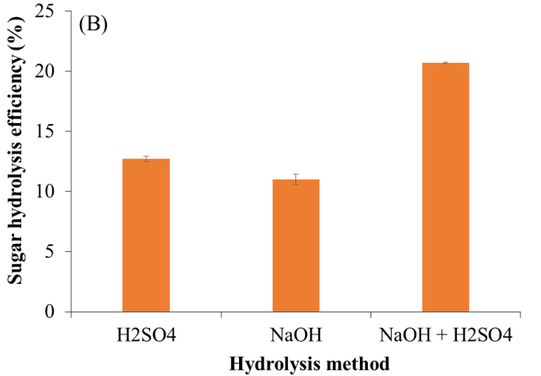
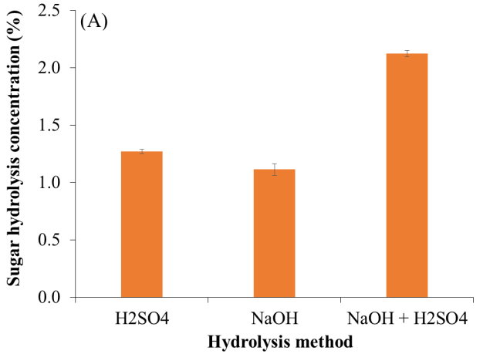
It can be seen that the hydrolysis method affected the yield and sugar content from rice straw. The average sugar content in the acid hydrolysate was measured as 1.2 g/L which was slightly higher than 1.1 g/L determined for the alkaline hydrolysate (Figure 1A). This data agreed with results reported by Kim et al. (2022), showing that reducing sugars produced by 0.5 % H₂SO₄ was 16.8 g/L which was remarkably higher than 1 g/L determined for NaOH or NH₄OH treatment [18]. This is attributed to alkali hydrolysis can delignify lignin part [19] and cleave hydrogen bonds and covalent bonds in cellulose and hemicellulose [18], while acid hydrolysis cleaves strong chemical bonds [18]. Notably, the combined hydrolysis gave the highest sugar content of 2.2 g/L, which was two times higher than that of two separated hydrolysis methods (Figure 1A). This is reasonable because after alkaline treatment, a certain proportion of lignin was removed, exposing open structure of cellulose-hemicellulose for the acid agent to further degrade and hydrolyze for saccharides generation [20].
Figure 1. Total reducing sugar production (A) and hydrolysis efficiency (B) from rice straw by H₂SO₄, NaOH and combined NaOH + H₂SO₄ methods.
Regarding hydrolysis efficiency, treatment with 10 % H₂SO₄ at 121℃ for 20 minutes gave a hydrolysis efficiency of 12.7 %. Similarly, the treatment with 10 % NaOH boiled for 2 h resulted in a sugar yield of 11 %. However, the combined method using NaOH + H₂SO₄ gave the rice straw sugar hydrolysis efficiency of up to 20.69 % (Figure 1B). The obtained data demonstrated that the combined method effectively hydrolyzed and significantly increased the amount of sugar in the hydrolysate compared to the hydrolysis method using only one agent of alkaline or acid.
It was also noted that different treatment methods resulted in different reducing sugar profiles. Data reported in Figure 2 shows that glucose, xylose and arabinose were the most abundant monosaccharides detected in rice straw hydrolysate. The concentration of glucose, xylose, and arabinose were determined in the range of 0.76 – 1.1, 0.13 – 0.76, and 0.25 – 0.27 g/L, respectively, which accounted for 51 – 74, 11 – 36 and 8 – 28 % of the total reducing sugar, respectively. Glucose concentration is the highest level due to cellulose composition in rice straw is the largest level of 43 %, following is hemicellulose of 25 %. Reducing sugar profile data displayed the linear relationship to total reducing sugar production by different hydrolytic methods.
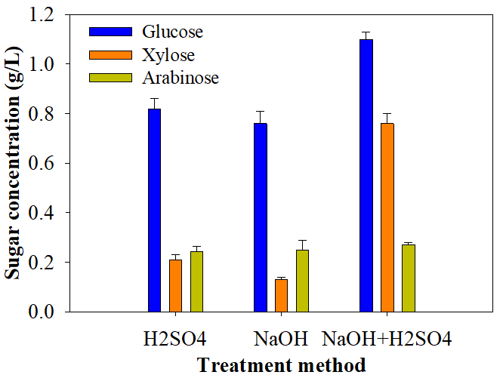
Figure 2. Monosaccharide composition of rice straw hydrolysate produced by different treatment methods (n = 3).
3.2. Growth of algal Scenedesmus sp. in rice straw hydrolysate
Chemical-derived hydrolysate of rice straw was a complex mixture that contained not only sugar but also inhibitors (levunilic acid, 5-HMF, and furfural) for microalgal growth [18]. Our early investigation revealed that the undiluted hydrolysate significantly inhibited the algal growth [6]. Therefore, the hydrolysate was diluted to different rates for examination of growth of Scenedesmus sp. Data shown in Figure 3A indicated that Scenedesmus sp. grew well in the acid hydrolysate at a 50 %, 25 %, 10 % dilution, and the control obtaining optical density of 0.88, 0.85, 0.46, and 0.40 Abs at day 10 of the cultivation, respectively. Scenedesmus sp. exhibited a lower growth in the 50%, 25 % and 10 % diluted alkaline hydrolysate, achieving optical density of 0.47, 0.49, and 0.52 Abs at day 10 of the cultivation, respectively (Figure 3B).
Notably, Scenedesmus sp. achieved optical density of 1.5, 0.95, and 0.52 Abs when the algal was grown in the 50 %, 25 %, and 10 % diluted hydrolysate from the combined method (Figure 3C). In all experiments, the control exhibited growth of the algal train in phototrophic mode, obtaining the adsorbance at 740 nm of around 0.41 Abs during 10 days of the cultivation (Figure 3), which was slightly lower than those achieved in the mixotrophic modes with rice straw hydrolysate supplements. The highest density of algal biomass was obtained with a 50 % dilution of the rice straw hydrolyzate, which was nearly 1.6 times that of the algal biomass obtained with 25 % dilution and about 3 times that of the algal biomass obtained with a 10 % dilution rate. It was noted that 50 % dilution significantly minimized inhibiting effects of several chemicals for the development of the microalgal to obtain the optimal growth of Scenedesmus sp [6, 18].
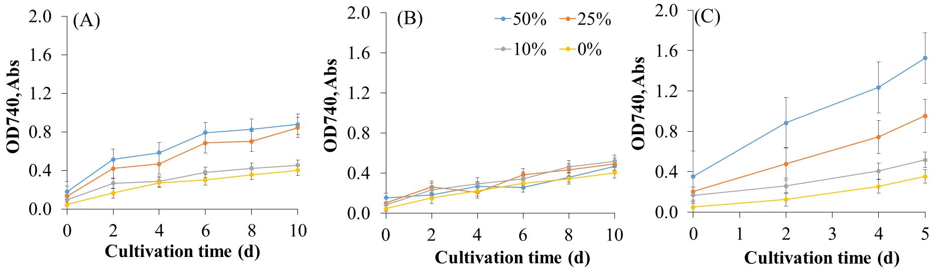
Figure 3. The growth of the algae Scenedesmus sp. in rice straw hydrolysate pretreated with H₂SO₄ (A), NaOH (B) and NaOH-H₂SO₄ (C).
3.3. Sugar utilization efficiency by Scenedesmus sp. in rice straw hydrolysis
Sugar utilization efficiency by Scenedesmus sp. is shown in Figure 4. Data indicates that the sugar utilization efficiency of Scenedesmus sp. ranged between 72 % and 87 % for the NaOH-based hydrolysate. The highest consumption of sugar was observed when 50 %- and 25 %-diluted hydrolysate were used, whereas the lower efficiency of sugar consumption was determined for 10 %-diluted hydrolysate. This was reasonable because at a lower dilution rate, a high concentration of inhibitors negatively affected the algal growth, consequently resulting in lower sugar utilization. Similarly, the sugar utilization efficiency of Scenedesmus sp. when it grew on H₂SO₄-based and NaOH/H₂SO₄-based hydrolysates was determined 78 – 95 % and 70 – 79 %, respectively. The lower sugar utilization efficiency in NaOH/H₂SO₄-based hydrolysates was observed because the data was measured on day 5 of the cultivation (Figure 3C), whereas data reported for H₂SO₄-based and NaOH-based hydrolysates was assayed on day 10 of the cultivation (Figure 3A-B).
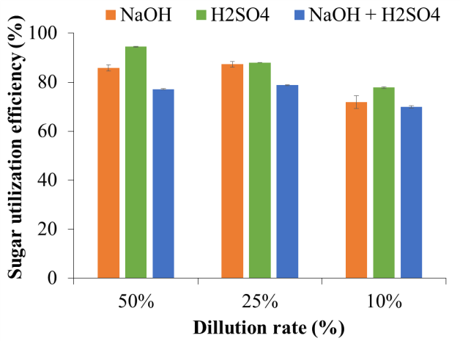
Figure 4. Sugar utilization efficiency of Scenedesmus sp. from rice straw hydrolysate. NaOH-treated hydrolysate (A), H₂SO₄-treated hydrolysate (B) and NaOH+H₂SO₄-treated hydrolysate (C).
This study confirms that rice straw is a rich source of carbohydrates after being chemically treated with H₂SO₄ and NaOH to cultivate the microalgae Scenedesmus sp. Similar to the results obtained, the hydrolysis product from rice straw was used as a carbon source for polyunsaturated fatty acids (PUFA) production from Chlorella pyrenoidosa ZTY4. A sugar concentration of 10 g/L was obtained by a post-enzymatic hydrolysis process. The study showed that Chlorella pyrenoidosa grew well in rice straw hydrolysate, reaching biomass concentrations of 4.2 - 5.0 g/L for 6 days of the cultivation. The algal lipid content of the cell was determined up to 66.4 % [21]. El-Gamal et al. also reported a 15-day heterotrophic cultivation of microalgae Chlorella vulgaris and Arthrospira platensis on rice straw pretreated with AHP as a low-cost carbon source [22].
3.3. Biorefinery of rice straw using Scenedesmus sp. for circular economy development, challenges and perspectives
Major biochemical compositions of Scenedesmus sp. grown in different rice straw hydrolysates are reported in Table 1. Results show that protein, lipid, and carbohydrate content of Scenedesmus sp. biomass varied widely when the algal was grown in different hydrolysates with different dilution rates. Generally, protein, lipid and carbohydrate contents were determined as 25.7 – 45 %, 13.5 - 24.5 % and 25.4 - 42.2 %, respectively. Protein and lipids tended to accumulate higher content when Scenedesmus sp. grew in NaOH/H₂SO₄-based hydrolysate, whereas carbohydrates can reach a higher proportion in NaOH-based or H₂SO₄-based hydrolysate. In any case, Scenedesmus sp. biomass provides rich protein supplied for animal and aquafeed production [23], lipid fractionized and purified for production of nutraceuticals, food, and biofuels [24], carbohydrates hydrolyzed for chemical productions (ethanol, lactic acid, etc.) [25]
Table 1. Biochemical content of Scenedesmus sp. grown in different rice straw hydrolysates (n = 3).
Hydrolysate | Protein  (wt.% DCW) | Lipid  (wt.% DCW) | Carbohydrate  (wt.% DCW)
50 % NaOH-based hydrolysate | 36.6 ± 3.6 | 18.3 ± 0.9 | 27.4 ± 2.9
25 % NaOH-based hydrolysate | 32.4 ± 3.1 | 19.6 ± 1.1 | 31.4 ± 3.5
10 % NaOH-based hydrolysate | 29.2 ± 1.9 | 19.5 ± 2.5 | 35.2 ± 5.1
50 % H₂SO₄-based hydrolysate | 25.7 ± 1.5 | 13.5 ± 0.6 | 42.2 ± 3.7
25 % H₂SO₄-based hydrolysate | 37.6 ± 3.2 | 21.3 ± 2.4 | 32.7 ± 3.5
10 % H₂SO₄-based hydrolysate | 35.7 ± 4.1 | 19.3 ± 2.1 | 34.6 ± 2.7
50 % NaOH+H₂SO₄-based hydrolysate | 38.7 ± 2.9 | 22.6 ± 1.7 | 31.7 ± 3.7
25 % NaOH+H₂SO₄-based hydrolysate | 41.2 ± 0.9 | 23.3 ± 2.7 | 30.4 ± 1.8
10 % NaOH+H₂SO₄-based hydrolysate | 45.0 ± 2.5 | 24.5 ± 1.9 | 25.4 ± 4.5
DCW: Dry cell weight
The bioprocess industry based on microalgae is constantly seeking to obtain useful products from the highly abundant lignocellulosic feedstock. Although microalgae have been demonstrated to display excellent capability in the consumption of five-carbon and six-carbon sugars from lignocellulosic materials (e.g., rice straw) for the production of high-value molecules such as protein, lipid, pigments, etc, the processing of lignocelluloses into reducing sugars-rich hydrolysates is a costly process due to the strong-crystalline structure of lignocellulose materials. Chemical methods are difficult to meet the demand to completely convert lignocelluloses to sugars because of the environmental issue. Biochemical process based on enzymes is a greener alternative approach for processing lignocellulosic biomass. However, one of the crucial challenging factors is in association with the expression levels, stability, and cost-effectiveness of the lignocellulose-degrading enzymes composed of cellulases, hemicellulases, lignases, and other accessory proteins in a non-competing, progressive, and synergetic order, in one complex. The challenge has ever been the successful assembly of an entire suite of these enzymes that could function optimally at the same time and under different conditions to completely digest lignocellulosic biomass to simple sugars. Many cellulase improvement practices and enzyme systems (i.e., cell-free or whole-cell) have surfaced and presently the fraternity is witnessing a gradual shift towards the cell-surface display system. Nevertheless, the remaining challenge was the achievement of high-level expressions necessary for industrial use at low cost for sugar production. To further improve lignocellulose activity, techniques such as directed evolution and rational design have ever been used for harnessing glycosylation in a ‘green’ approach. The success of the approach is a promising application of consolidated bioprocessing of lignocelluloses to reducing sugars, which are substrates for microalgae production.
4. Conclusions
Pretreatments of rice straw with NaOH, H₂SO₄, and NaOH+H₂SO₄ were studied, achieving hydrolysates with reduction sugar concentrations of 1.1, 1.2, and 2.2 g/L, and equivalent sugar hydrolysis efficiencies of 11, 12.7, and 20.7 %, respectively. The Scenedesmus sp. strain was successfully grown in rice straw hydrolysates derived from NaOH, H₂SO₄, and NaOH+H₂SO₄ treatments. The optimal growth of Scenedesmus sp. was recorded in the hydrolysate with 50 % dilution, achieving biomass density of 0.52 - 1.5 Abs with sugar utilization efficiency of 70 – 94 %. In addition, the harvested Scenedesmus sp. biomass comprised of protein, lipid and carbohydrate contents were determined as 25.7 – 4 5%, 13.5 - 24.5 %, and 25.4 - 42.2 %, respectively. Biorefinery of rice straw using bioprocess of microalgae can create a circular economy with low-carbon emission. Despite of its promising, processing of lignocelluloses into reducing sugars-rich hydrolysates for microalgae production is very challenging. The future work is further application of enzymatic hydrolysis in a consolidated bioprocessing for chemical-treated rice straw, expecting to produce high concentration of reducing sugars with 100 % degradation efficiency to enhance biomass production from Scenedesmus sp.
Acknowledgements. This research is supported by Graduate University of Science and Technology, Viet Nam under the grant number GUST.STS.ĐT2017-ST03 and GUST.STS.ĐT2017-MT01.
CRediT authorship contribution statement. Do Thi Cam Van: Writing, Methodology, Investigation, Funding acquisition. Pham Thi Mai Huong: Formal analysis, Methodology.
Declaration of competing interest. The authors declare that they have no known competing financial interests or personal relationships that could have appeared to influence the work reported in this paper.
References
- Nguyen H. S., Bui T. P. L. and Ngo D. M. - Sustainable rice straw management in Viet Nam: Current situation, challenges and potential. J. Vietnam Agric. Sci. Technol. 1 (3) (2018) 113-120.
- Nguyen H. V., Nguyen C. D., Tran T. V., Hau H. D., Nguyen N. T. and Gummert M. - Energy efficiency, greenhouse gas emissions, and cost of rice straw collection in the mekong river delta of Viet Nam, Field Crops Res. 198 (2016) 16-22. https://doi.org/10.1016/j.fcr.2016.08.024.
- Wang X., Yang Z., Liu X., Huang G., Xiao W. and Han L. - The composition characteristics of different crop straw types and their multivariate analysis and comparison. Waste Manag. 110 (2020) 87-97. https://doi.org/10.1016/ j.wasman.2020.05.018.
- Le T. M., Tran U. P. N., Duong Y. H. P., Nguyen Q. D., Tran V. T., Mai P. T. and Le P. K. - Sustainable bioethanol and value-added chemicals production from paddy residues at pilot scale. Clean Technol. Environ. Policy. 24 (1) (2022) 185-197. https://doi.org/10.1007/s10098-021-02097-w.
- Do N. H., Pham H. H., Le T. M., Lauwaert J., Diels L., Verberckmoes A., Do N. H. N., Tran V. T. and Le P. K. - The novel method to reduce the silica content in lignin recovered from black liquor originating from rice straw. Sci. Rep. 10 (1) (2020) 21263. https://doi.org/10.1038/s41598-020-77867-5.
- Do C. V. T., Lam V. T., Nguyen P. D. T., Tran D. T., Ngo Q. A. and Le T. G. - Recovery of carbon from rice straw for production of high-value products by Chlorella sorokiniana TH01 through mixotrophic cultivation. Biochem. Eng. J. 197 (2023) 108966. https://doi.org/10.1016/j.bej.2023.108966.
- Zhan J., Rong J. and Wang Q. - Mixotrophic cultivation, a preferable microalgae cultivation mode for biomass/bioenergy production, and bioremediation, advances and prospect. Int. J. Hydrogen Energy. 42 (12) (2017) 8505-8517. https://doi.org/10.1016/ j.ijhydene.2016.12.021.
- Olguin E. J., Sanchez G. G., Arias O., Melo F. J., Gonzalez P. R. E., Cruz L., Philippis D. R. and Adessi A. - Microalgae-based biorefineries: Challenges and future trends to produce carbohydrate enriched biomass, high-added value products and bioactive compounds. Biology (Basel). 11 (8) (2022). https://doi.org/10.3390/biology11081146.
- Manzoor M., Ahmad Q. A., Aslam A., Jabeen F., Rasul A., Schenk P. M. and Qazi J. I. - Mixotrophic cultivation of Scenedesmus dimorphus in sugarcane bagasse hydrolysate. Environ Prog Sustain. 39 (2) (2020) e13334. https://doi.org/10.1002/ep.13334.
- Saadaoui I., Rasheed R., Aguilar A., Cherif M., Al Jabri H., Sayadi S. and Manning S. R. - Microalgal-based feed: promising alternative feedstocks for livestock and poultry production. J Anim Sci Biotechnol. 12 (1) (2021) 76. https://doi.org/10.1186/s40104-021-00593-z.
- Yang S., Liu G., Meng Y., Wang P., Zhou S. and Shang H. - Utilization of xylose as a carbon source for mixotrophic growth of Scenedesmus obliquus. Bioresour. Technol. 172 (2014) 180-185. https://doi.org/10.1016/j.biortech.2014.08.122.
- Do C. V. T., Nguyen N. T. T., Pham M. H. T., Pham T. Y. T., Ngo V. G., Giang Le T. and Tran T. D. - Central composite design for simultaneously optimizing biomass and lutein production by a mixotrophic Chlorella sorokiniana TH01. Biochem. Eng. J. 177 (2022) 108231. https://doi.org/10.1016/j.bej.2021.108231.
- Sluiter J. B., Ruiz R. O., Scarlata C. J., Sluiter A. D. and Templeton D. W. - Compositional analysis of lignocellulosic feedstocks. 1. Review and description of methods. J. Agric. Food Chem. 58 (16) (2010) 9043-9053. https://doi.org/ 10.1021/jf1008023.
- Rosado M. J., Marques G., Rencoret J., Gutierrez A. and Del Rio J. C. - Chemical composition of lipophilic compounds from rice (Oryza sativa) straw: An attractive feedstock for obtaining valuable phytochemicals. Front Plant Sci. 13 (2022) 868319. https://doi.org/10.3389/fpls.2022.868319.
- Jabeen S., Gao X., Altarawneh M., Hayashi J.i., Zhang M. and Dlugogorski B. Z. - Analytical procedure for proximate analysis of algal biomass: Case study for Spirulina platensis and Chlorella vulgaris. Energ Fuel. 34 (1) (2020) 474-482. https://doi.org/ 10.1021/acs.energyfuels.9b03156.
- Tewari H. K., Marwaha S. S., Kennedy J. F. and Singh L. - Evaluation of acids and cellulase enzyme for the effective hydrolysis of agricultural lignocellulosic residues. J. Chem. Technol. Biotechnol. 41 (4) (1988) 261-275. https://doi.org/10.1002/ jctb.280410403.
- Tran D. T., Ta T. N., Do T. H. N., Pham T. M., Doan T. B. H., Mai T. H. T., Do T. C. V., Le T. G. and Nguyen V. T. - Developing a mini biodiesel production line via sequential conversion to purification from Scenedesmus acuminatus S4 grown in domestic wastewater. J. Chem. Technol. Biotechnol. 95 (8) (2020) 2159-2170. https://doi.org/ 10.1002/jctb.6402.
- Kim D. H., Jo I. S., Kang B. J., Lee B. D., Kumar S., Kim S. H. and Yoon J. J. - Evaluation of bio-hydrogen production using rice straw hydrolysate extracted by acid and alkali hydrolysis. International Int. J. Hydrogen Energy. 47 (88) (2022) 37385-37393. https://doi.org/10.1016/j.ijhydene.2021.12.177.
- Tsegaye B., Balomajumder C. and Roy P. - Alkali delignification and Bacillus sp. BMP01 hydrolysis of rice straw for enhancing biofuel yields. Bull Natl Res Cent. 43 (1) (2019). https://doi.org/10.1186/s42269-019-0175-x.
- Ashoor S., Mallapureddy K. K. and Sukumaran R. K. - Sequential mild acid and alkali pretreatment of rice straw to improve enzymatic saccharification for bioethanol production. Prep Biochem Biotech. 53 (3) (2023) 231-238. https://doi.org/10.1080/ 10826068.2022.2073597.
- Zhang T.Y., Wu Y.H., Wang J.H., Wang X.X., Deantes-Espinosa V. M., Dao G.H., Tong X. and Hu H.Y. - Heterotrophic cultivation of microalgae in straw lignocellulose hydrolysate for production of high-value biomass rich in polyunsaturated fatty acids (PUFA). J. Chem. Eng. 367 (2019) 37-44. https://doi.org/10.1016/j.cej.2019.02.049.
- El-Gamal A. D., Khedr F. G., Tohamy E. Y. and Abouelwafa A. M. - Safe technological trend towards the production of bioethanol from algal biomass grown on rice straw. Egypt. J. Phycology. 20 (1) (2019) 51-83. https://doi.org/10.21608/egyjs.2019.116020.
- Kusmayadi A., Leong Y. K., Yen H. W., Huang C. Y. and Chang J. S. - Microalgae as sustainable food and feed sources for animals and humans - Biotechnological and environmental aspects. Chemosphere. 271 (2021) 129800. https://doi.org/10.1016/ j.chemosphere.2021.129800.
- Zhu Z., Sun J., Fa Y., Liu X. and Lindblad P. - Enhancing microalgal lipid accumulation for biofuel production. Front Microbiol. 13 (2022) 1024441. https://doi.org/10.3389/ fmicb.2022.1024441.
- Banerjee S., Das D., Atta A. and Shanmugam P. - Chapter 12 - Obtaining commodity chemicals by bio-refining of algal biomass. in Algae and Aquatic Macrophytes in Cities. Elsevier, 2022, pp. 261-270.

