AUTHOR GUIDELINES

BEFORE YOU BEGIN
Please see our information pages on PUBLICATION ETHICS
A. GENERAL INSTRUCTIONS
Submitted manuscripts are the original works that are not plagiarized, and have not been published or submitted elsewhere. Author(s) should take collective responsibility for submitted and published work.
1. General manuscript structure
You may choose to submit your manuscript as a single Word file to be used in the refereeing process. Manuscripts should be written in clear, straightforward full English. Manuscripts including figures and tables should be formatted in A4 paper size, top margin 1.36'', bottom margin 1.61'', left 1.18'', right 0.95'', gutter 0'' and gutter position: left; line spacing:1.5 line, before 0pt, after 0pt.
The manuscript should be structured using headlines and sub-headlines, but without numbering according to the following sections:
TITLE
Use capital letters, except the scientific name of biotaxa. The title contains a short, precise and meaningful title.
Author name(s) with at least one first and the family name given in full, current address(es) of the authors;
* Corresponding author: E-mail address(es) of the corresponding author, who is clearly marked with an asterisk (*). Ensure that the e-mail address is given and that contact details are kept up to date by the corresponding author;
ABSTRACT
The abstract should contain up to 400 words. The abstract should state briefly the purpose of the research. It should state concisely the scope of the principal work, and give the principal findings the principal results. An abstract is often presented separately from the article, so it must be able to stand alone. Also, non-standard or uncommon abbreviations should be avoided, but if essential they must be defined at their first mention in the abstract itself.
Keywords: A maximum of 10 keywords may be given and avoiding general, plural terms and multiple concepts (avoid, for example, 'and, 'of'). These keywords will be used for indexing purposes.
INTRODUCTION
The introduction should state in several sentences that give what the main research hypothesis/question(s) are interested and introduce the main idea of the research, capture the interest of readers and tell why the topic is important. The introduction should conclude with a brief statement of the rationale for the study, the hypothesis that was addressed, or the overall purpose of the experiments reported and should provide a comment about whether that aim was achieved.
MATERIALS AND METHODS
In this paragraph, the author should describe the materials used in the study, explain how the materials were prepared for the study, describe the research protocol, explain how measurements were made and what calculations were performed, and state which statistical tests were done to analyze the data. All abbreviations used should be explained.
RESULTS
Results should be clear and concise. This section should provide statistical analyses of all of the experiments that are required to support the conclusions of the paper. Reserve extensive interpretation of the results for the Discussion section. Results are presented in the text integrated with effective tables and/or figures, not to describe results in the text in a way that is not redundant with information already presented in tables and/or figures. Present the results as concisely as possible in text, table(s), or figure(s) (see below). Avoid extensive use of graphs to present data that might be more concisely presented in the text or tables. Number figures and tables in the order in which they are cited in the text, and be sure to cite all figures and tables. Styles and fonts should match those in the main body of the article. The section may be divided into subsections, each with a concise subheading.
DISCUSSION
The discussion answers where the results make sense in terms of practice or theoretical considerations. Interpretation of findings, limitations, and implications or recommendations for future research. What are the limitations and unsettled points in the results?
The Discussion should provide an interpretation of the results of previously published work and the experimental system used. It should not contain extensive repetition of the Results or reiteration of the Introduction. This section should spell out the major conclusions of the work along with some explanation or speculation on the significance of these conclusions. The discussion should be concise and tightly argued.
CONCLUSION
The conclusions of the study may be presented in a short Conclusions section, which may stand alone or form a subsection. The conclusion demonstrates new findings in the research and how the ideas in the paper connect to what the author(s) have described in the introduction and discussed.
ACKNOWLEDGEMENTS
In acknowledgements, the author's thanks should be expressed to all organizations or individuals who provide assistance and supports for the research done.
REFERENCES (see Instructions for Authors B.2 and B.3 below)
Tables with captions and Figure legends. All pictures and photos should be sent separately.
2. Manuscript Submission
Our online submission system guides you stepwise through the process of entering your article details and uploading your files. All correspondence, including notification of the Editor's decision and requests for revision, is sent by e-mail.
3. Peer reviewing, submission of the final version, and publication
Manuscripts are subject to peer review. All manuscripts submitted to Academia Journal of Biology (JOB) will be independently reviewed by at least two experts in the corresponding area of research. Manuscripts rejected by reviewers will be informed to the author(s).
Once the manuscript is provisionally accepted, it is returned to the author with the Reviewer’s and Subject Editor's comments. The author is required to respond to each of the comments, however, the author should also justify any disagreement with the comments.
After the manuscript is accepted, the author(s) should submit an electronic version of the complete version plus all figures, tables, and correct forms for editing and typesetting.
Before the publication of the manuscript, the author will receive page proofs, preferably by e-mail in PDF format, the author should print out, correct, and return these within two weeks to: vjbio@vjs.ac.vn.
The journal reserves the right to publish the article with only the Editor's corrections should the author's corrections not reach the editorial office in time.
4. Page charges
There will not be any page charges for publishing in the JOB. The author will have to email the Editorial Office to check for suitability for publication before emailing the manuscript.
5. Reprints
The corresponding author will receive one hard copy reprint of the volume and a PDF file for use free of charge.
B. INSTRUCTIONS FOR AUTHORS
1. General Manuscript Structure
Please use the font Times New Roman, size 12, 1.5 line spacing for all parts of your manuscript (including the main text, abstract, references, and figure captions), and enter the page number on every page. The manuscript should be structured using headlines and sub-headlines without numbering.
Tables and figures should be organized to fit the page format. Tables and figures must have their headings. Lengthy headings are to be avoided, but supplementary notes are allowed. Tables and figures should be numbered with Arabic numbers, e.g. Table 1, Table 2, Tables 3,4; Figure 1, Figure 2, Figures 3,4… etc. (see sub-headlines Table and Figure below)
Genus and species names are written in italic. Taxonomic descriptions must comply with the rules of ICZN (4thedition), see an example in International Commission on Zoological Nomenclature at https://www.iczn.org/. Consistently use abbreviations (e.g.: gen. n., sp. n., comb. n., stat. n., etc.).
2. References
Unpublished results are not listed in the “Reference” section. Authors should be sure that they have properly placed the surname in front of the given name in alphabetical lists of authors' names.
In the reference section, write the author's surname, paper title, and journal name in full, for example:
Nguyen Ngoc Lan, Vu Van Dung and Nguyen Huy Hoang, 2019. Isolation and identification of indole acetic acid-producing bacteria from the coasts of Ben Tre and Tra Vinh provinces. Academia Journal of Biology, 41(4): 55-67.
However, the abbreviation of journal names can be written following ISI Journal Title Abbreviations at: http://www.zxlei.cn/science/isi/E_abrvjt.html
The references should follow the formats of the examples listed below precisely:
Journal Article
Lohot V. D., Sharma-Natu P., Pandey R., Ghildiyal M. C., 2010. ADP-glucose pyrophosphorylase activity in relation to starch accumulation and grain growth in wheat cultivars. Curr. Sci., 98(3): 427–430.
Minh B. Q., Schmidt H. A., Chernomor O., Schrempf D., Woodhams M. D., von Haeseler A., Lanfear R., 2020. IQ-TREE 2: New models and efficient methods for phylogenetic inference in the genomic era. Molecular and Biological Evolution, 37: 1530–1534. https://doi.org/10.1093/molbev/msaa015.
Caly L., Druce J. D., Catton M. G., Jans D. A., Wagstaff K. M., 2020. The FDA-approved drug ivermectin inhibits the replication of SARS-CoV-2 in vitro. Antiviral Research. https://doi.org/10.1016/j.antiviral.2020.104787.
Nguyen Hai Van, Nguyen Thi Minh, 2017. Research on using endophytic bacteria isolated from different ecosystems. Vietnam J Agri Sci., 15: 605–618 (In Vietnamese with English summary).
Book
Weissbach A., Weissbach H., 1988. Methods for Plant Molecular Biology. Academic Press Inc, California, USA, pp. 450.
Le Nhu Hau, Nguyen Huu Dai, 2010. Vietnamese Gracilaria resources and used. Natural Science and Technology Publishing, pp. 247 (In Vietnamese).
Book Chapter
Brinkhuis B. H., 1985. Handbook of Phycological Methods, Ecological Field Methods: Macroalgae. Cambridge: Cambridge University Press, pp. 461–477

Nguyen Thi Bich Thuy, 2014. Research on biological characteristics and propagation technology, cultivation of mushroom Pleurotus eryngii and Trametes versicolor in Vietnam. pp. 34-143 (In Vietnamese).
Proceedings
Miorin L., Kehrer T., Sanchez-Aparicio M. T., Zhang K., Cohen P., Patel R. S., ... & García-Sastre A., 2020. SARS-CoV-2 Orf6 hijacks Nup98 to block STAT nuclear import and antagonize interferon signaling. Proceedings of the National Academy of Sciences, 117(45): 28344−28354.

Nguyen Thi Huong, Le Nhu Hau, Vu Thi Mo, 2010. Preliminary study on storage of seaweeds to establish ex-situ conservation. Proceedings of the scientific conference celebrating the 35th anniversary of the establishment of the Vietnam Academy of Science and Technology: 254−259. (In Vietnamese with English summary).
From website
As a minimum, the full URL should be given and the date when the reference was last accessed. Any further information, if known (DOI, author names, dates, reference to a source publication, etc.)
Wikipedia, 2021. The free encyclopedia. Glyptostrobus pensilis. https://en.wikipedia.org/wiki/Glyptostrobus_pensilis. [accessed: 21/05/2021]
VASEP, 2019. http://vasep.com.vn/Tin-Tuc/1200_58730/Xuat-khau-thuy-san-nam-2019-can-dich-voi-86-ty-USD.htm (accessed: 18/12/2020).
Patents
Maliga P., 1996. Method for Producing Male Sterility in Plant and Use thereof in Production Hybrid Seed. Patent Number 5,530,191
3. Citation in text
Please ensure that every reference cited in the text is also present in the reference list (and vice versa). Any references cited in the abstract must be given in full.
Reference style
Text: All citations in the text should refer to:
1. Single author: The author's name (without initials, unless there is ambiguity) and the year of publication; e.g.: Wilkinson (2021) or (Wilkinson, 2021)
2. Two authors: Both two authors' names and the year of publication. Two authors are named and connected by "&"; e.g.: Wilkinson & Truong (2021) or (Wilkinson & Truong, 2021).
3. Three or more authors: First author's name followed by "et al." and the year of publication; e.g.: Truong et al. (2020) or (Truong et al., 2021)
Several citations are separated by a semicolon “;” as: (Wilkinson & Smith, 2016; Smith et al., 2018; Truong, 2020).
4. Tables
Tables should be clearly structured, and do not repeat any information that is already given in text or illustrations, the text must refer to every table. Tables should be provided at the end of the paper on separate pages, small, short tables (no wider than one column) may be integrated within the text. Each abbreviation used in the table has to be explained in the caption or in the footnotes.
5. Figures
Please submit the files as TIF(TIFF) or JPEG (Photoshop) and it is better not to reduce the layers to one layer. Please submit figures electronically, with a minimum resolution of 300 dpi.
Several figures grouped together with one common legend need to be numbered using Arial letters regular bold: a, b, c … size 12, aligned top left.

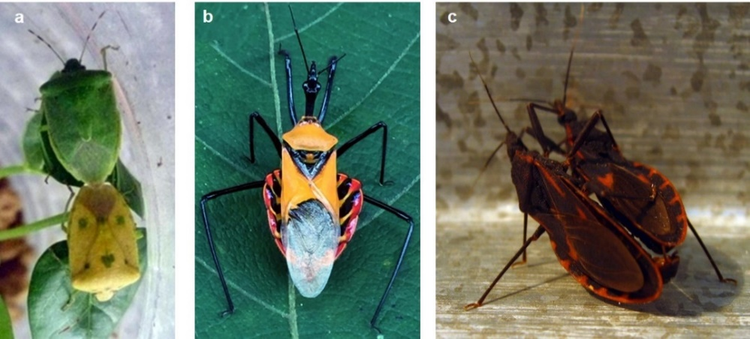
Figure 1. The species of order Heteroptera
a. Harmful bugs; b. Assassin bugs; c. Blood-sucking bugs

For individual queries please contact the Editorial Office (E-mail: tapchisinhhoc@vjs.ac.vn)

Submission Preparation Checklist
As part of the submission process, authors are required to check off their submission's compliance with all of the following items, and submissions may be returned to authors that do not adhere to these guidelines.
- The submission has not been previously published, nor is it before another journal for consideration (or an explanation has been provided in Comments to the Editor).
- The submission file is in OpenOffice, Microsoft Word, RTF, or WordPerfect document file format.
- Where available, URLs for the references have been provided.
- The text is single-spaced; uses a 12-point font; employs italics, rather than underlining (except with URL addresses); and all illustrations, figures, and tables are placed within the text at the appropriate points, rather than at the end.
- The text adheres to the stylistic and bibliographic requirements outlined in the Author Guidelines, which are found in About the Journal.
- If submitting to a peer-reviewed section of the journal, the instructions in Ensuring a Blind Review have been followed.
Privacy Statement
The names and email addresses entered in this journal site will be used exclusively for the stated purposes of this journal and will not be made available for any other purpose or to any other party.
Copyright Notice

Academia Journal of Biology (AJB) is an open access and peer-reviewed journal. All academic publications could be made free to read and download for everyone.

