OPTIMIZATION OF FERMENTATION CONDITIONS FOR SQUALENE PRODUCTION OF SQUALENE BY HETEROTROPHIC MARINE MICROALGAE SCHIZOCHYTRIUM MANGROVEI PQ6
Nguyen Cam Ha^{1,2}, Hoang Thi Minh Hien¹*, Le Thi Thom¹, Hoang Thi Huong Quynh¹, Dang Diem Hong¹*
¹Institute of Biotechnology, Vietnam Academy of Science and Technology, 18 Hoang Quoc Viet, Cau Giay, Hanoi, Vietnam
²Graduate University of Science and Technology, Vietnam Academy of Science and Technology, 18 Hoang Quoc Viet, Cau Giay, Hanoi, Vietnam
*hoangminhhien@yahoo.com, ddhong60vn@yahoo.com

ABTRACT
Squalene is currently known as chemopreventive agents in reducing the incident of coronary heart disease and cancer. It is also a strong antioxidant used extensively in the food and cosmetic industries. Microbial sources of squalene are being explored in recent years. The objective of this study was to investigate fermentation conditions of Schizochytrium mangrovei PQ6 for high squalene production in 30L bioreactor. Squalene production was influenced by various nutritional factors such as glucose, nitrogen, vitamins etc. and physical factors such as batch and fed-batch fermentation. Our study established that fed-batch fermentation with nitrogen source of 1.2% yeast extract and 6.4% monosodium glutamate and 0.4% mixture of vitamin B1, 6 and 12 as optimal culture condition for maximal production of squalene by S. mangrovei PQ6. In fed-batch culture, the glucose concentration feeding was added up to 22% into the culture at 36 h of fermentation. The maximum squalene production was achieved 6.9 ± 0.1 g/L at 48 h of fed-batch fermentation, respectively. The values were 2-3 times more than that in fed-batch cultivation without adding mixture of vitamins and 4-6 times more than that in batch cultivation. Our obtained results are a breakthrough for the development of alternative squalene source from heterotrophic marine microalgae of Schizochytrium mangrovei PQ6 species for health-promoting functional foods.
Key word: Biomass, fed-batch culture, glucose, Schizochytrium mangrovei PQ6, squalene, vitamins.

INTRODUCTION
Squalene (2, 6, 10, 15, 19, 23-hexamethyltetracosa - 2, 6, 10, 14, 18, 22-hexaene), a dehydro-triterpenic hydrocarbon (C₃₀H₅₀) with six double bonds, is a basic intermediary metabolite for the biosynthesis of sterols and triterpenes in plants and animals [17]. Squalene is an important constituent in skin-care products or antioxidant agents in the industry. It has been proved that squalene is a strong antioxidant, anticancer and hypocholesterolemic effects [18]. The daily consumption of squalene is effective in reducing incidence of coronary heart disease and varieties of cancers. The daily intake of 500 mg squalene was suggested to play an important role in improving human health and nutrition [10].
The current major commercial sources of squalene are liver oils of deep-sea sharks and plant seed oils. However, the continuous supply and future availability of the liver oils are in doubt because of the concerns over the preservation of marine wildlife and the effects of locality and seasonal variation on the crop production [2]. Thus, finding alternative sources of commercial squalene are being advanced for researchers.
Yeasts have been mentioned to possess the ability to produce squalene, but their content is relatively low (0.041 mg/g of biomass) and thus yeasts are not good source for squalene production on the large-scale [2]. In recent studies, microalgae as an alternative source of squalene have been explored and have some interesting results [11, 14]. Of all the microalgal groups, Schizochytrium species are regarded as a promising cell factory for the high production of squalene [6, 13]. Schizochytrium can growth rapidly and accumulate high content of squalene in heterotrophic conditions which completely eliminate the problem of light limitation in closed culture systems [6]. Some species of Schizochytrium contain squalene ranging from 0.15% to 20%, for example Aurantiochytrium mangrovei FB1 (0.162 mg/g of biomass), Schizochytrium mangrovei PQ6 (33 mg/g dry weight), and Aurantiochytrium sp. 18W.3a (171 mg/g dry weight) [7, 9, 13]. In additional, optimization of culture medium led to increase of squalene content and production. Jiang et al. [9] reported that the squalene level also depends on the cultivation time. While the squalene level reached 0.16 mg/g dry weight after 3 days, only 0.04 mg/g dry weight were found after 5 days in cultures of Schizochytrium mangrovei. The study of Fan et al. [5] showed that treatment of cells with the inhibitor terbinafine led to a squalene content of 0.5 mg/g biomass. This value was much higher than those previously reported in Scharomyces cerevisae (0.041 mg/g of biomass) and Torulaspora debrueckii (0.24 mg/g of biomass) [2]. Chen et al. [3] optimized the nitrogen source which enhanced the squalene content and yield in Aurantiochytrium sp. by 26.35 and 10.1%, respectively. With the same objective to optimizing the squalene production, Pore et al. [15] used a mixture of vitamin B₁, B₆, B₁₂ and showed that squalene titer of Schizochytrium sp. ATCC20888 and Aurantiochytrium sp. ATCC PRA 276 could reach 3.7 and 1.7 g/L, respectively.
In Vietnam, screening of microalgae species for squalene production also was carried out in Dept. of Algal Biotechnology, Institute of Biotechnology, Vietnam Academy of Science and Technology (VAST). The species-rich squalene was assigned to the Schizochytrium mangrovei PQ6 with squalene content of 33 mg/g dry weight in 30 and 100L bioreactors [7]. Moreover, Anh et al. [1] indicated that the use of an inhibitor of squalene monooxygenase in the sterol biosynthetic pathway, terbinafine, could influence the activity of squalene synthase and the accumulation of squalene in S. mangrovei PQ6. At terbinafine concentration of 100 μg/L, squalene content in flasks increased 56.44% compared to control. However, the squalene content and yield of strain PQ6 still remain low for commercial application and must further enhance through culture optimization. Therefore, the objective of this study was to investigate the effect of fermentation conditions such as initial glucose concentrations, nitrogen sources, mixture of vitamin B, and batch and fed-batch cultivation on growth and squalene production by Schizochytrium mangrovei PQ6 in 30L bioreactor.
MATERIALS AND METHODS
Algal strain
Heterotrophic marine microalgae Schizochytrium mangrovei PQ6 was isolated from Phu Quoc Island, Kien Giang province in 2006-2008 and deposited at Department of Algae Technology, Institute of Biotechnology, Vietnam Academy of Science and Technology.
Batch fermentation of S. mangrovei PQ6 at different glucose concentrations and nitrogen sources
Fermentation was carried out in a 30 L bioreactor (New Brunswick Scientific Co. Inc., Edison, NJ, USA) with working volume of 15 L of M12 medium (90 g/L glucose, 10 g/L yeast extract, and 17.5 g/L artificial seawater – ASW). The inoculum size was 2 - 3% of the total liquid volume in bioreactor. Temperature was kept at 25 - 35^{ο}C. Dissolved oxygen was maintained above 10% by manually increasing the stirring speed (Rushton blade impellers) from 250 rpm to a maximum of 450 rpm. The aeration rate was always 0.5 volume air (vol. medium)/min after filtering through a 0.2 mm filter. The medium pH was controlled within the range of 6.5-7.5. For investigating the effects glucose concentrations, cells were growth in M12 basal medium with glucose in different concentrations (of 3, 6, 9, 10, 12, and 22%). To study the effect of N sources, the cells were grown in M12 basal medium with 1% yeast extract or 1.2% yeast extract and 64.2 g/L monosodium glutamate. Samples were collected every 24 h for analysis of cell growth and squalene content by centrifugation at 3000 rpm for 10 min. The algal paste was washed three times with sterile distilled water and then dried to a constant weight in an oven at 80 ^{ο}C and stored in desiccators until use.
Fed-batch fermentation of S. mangrovei PQ6 with and without addition of vitamin mixture
First, fermentation was carried out in a 30 L bioreactor (New Brunswick Scientific Co. Inc., Edison, NJ, USA) with working volume of 15 L of CNT medium (75 g/L glucose, 12 g/L yeast extract, 64.2 g/L monosodium glutamate, 2.5 g/L NaCl, 9.6 g/L KH₂PO₄, 12 g/L MgSO₄, 1.2 g/L CaCl₂, 1.2 g/L NaHCO₃, 0.8 g/L KCl, 5.6 g/L trace elements) and the inoculum size was 2 - 3% of the total liquid volume in bioreactor. After 36 – 48 h, the substrate was fed continuously into the bioreactor with a peristaltic pump, at final glucose concentration feeding of 22%. Temperature was kept at 30 ^{ο}C during the fermentation. Dissolved oxygen was maintained above 10% by manually increasing the stirring speed (Rushton blade impellers) from 250 rpm to a maximum of 450 rpm. The aeration rate was always 0.5 volume air (vol. medium)/min after filtering through a 0.2 mm filter. The medium pH was controlled within the range of 6.5-7.5. For investigating the effects vitamin mixture, cells were growth in CNT basal medium with or without 1.4 g/L vitamin mixture (vitamin B₁ - 45 g/L, vitamin B₆ - 45 g/L, and vitamin B₁₂ - 0.25 g/L). Samples were taken every 12 h for analysis of cell growth, residual glucose concentration and squalene content by centrifugation at 3000 rpm for 10 min. The algal paste was washed three times with sterile distilled water and then dried to a constant weight in an oven at 80 ^{ο}C and stored in desiccators until use.
Determination of cell growth
Cell growth was determined by dry cell weight (DCW) and cell density as described by Hong et al. [8].
Determinaton of squalene content
Squalene was isolated from dried biomass of S. mangrovei PQ6 as described by Yue and Jiang [19] and identified by thin layer chromatography (TLC), high-performance liquid chromatography (HPLC) as described by Hoang et al. [7].
Determination of residual glucose content
Residual glucose concentration was determined by using Miller methods [12].

RESULTS AND DISSCUSION
Effect of initial glucose concentration on cell growth and squalene accumulation in batch fermentation
According to Fan et al. [5] and Nakazawa et al. [13], initial glucose concentration has great influence on growth rate and squalene accumulation of Aurantiochytrium spp. (species belong to the genus Thraustochytrids). Therefore, we determined the effect of initial glucose concentration on cell density, biomass and squalene production of S. mangrovei PQ6. The initial glucose concentrations tested were set at 3, 6, 9, 10, 12, and 22%.
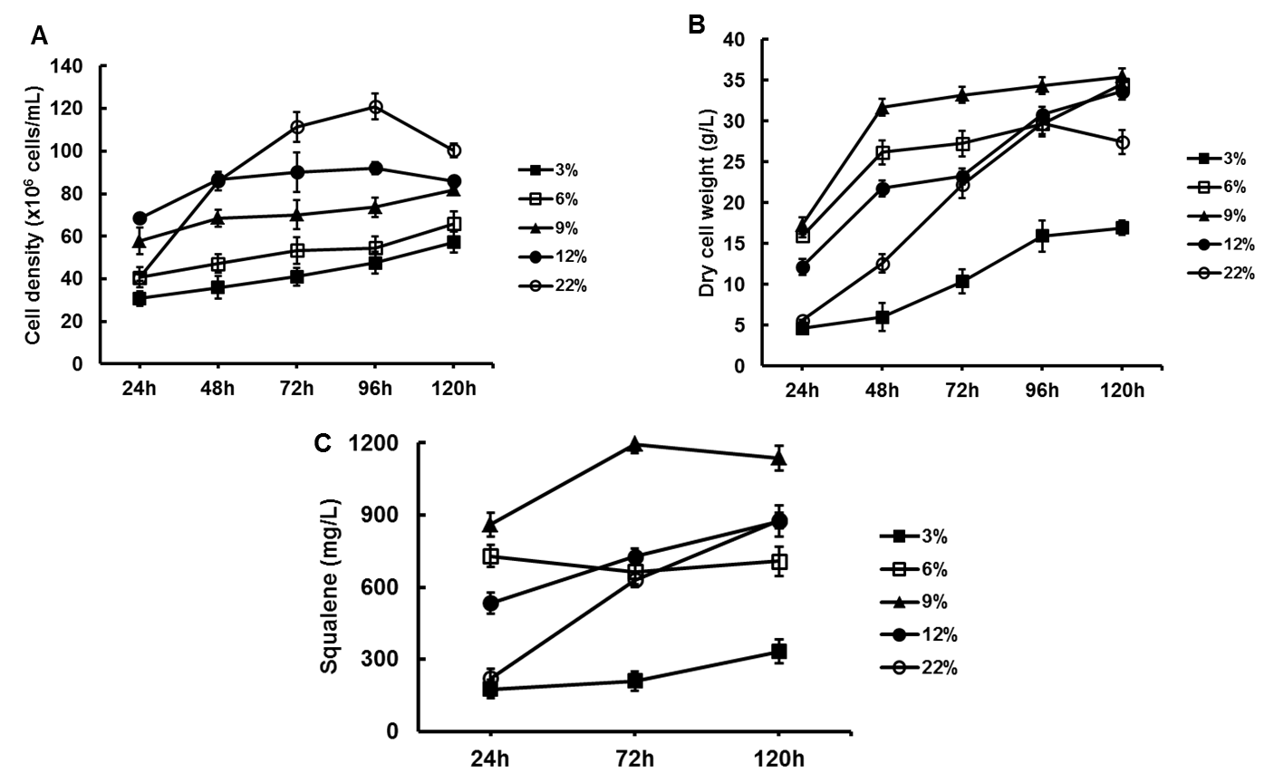

Figure 1: Effect of initial glucose concentrations on cell density (A), dry cell weight (B) and squalene production (C) in S. mangrovei PQ6.
The result in Figure 1 showed that cell density, dry cell weight (DCW) and squalene production of strain PQ6 increased with culture time at all tested glucose concentration. Therein, cell density, DCW and squalene production of S. mangrovei have increased strongly when glucose concentration increased from 3 to 9%. However, these values decreased at the glucose concentration of 12 and 22%, except the cell density (Figure 1 and 2). As suggested by Qu et al. [16], the inhibitory effect of high glucose concentration on squalene production might be due to the catabolism repression. Glucose is a rapidly metabolizable carbon - energy that will increase in the intracellular ATP concentration, causing the repression of enzymes biosynthesis and results in slower metabolization of energy source.

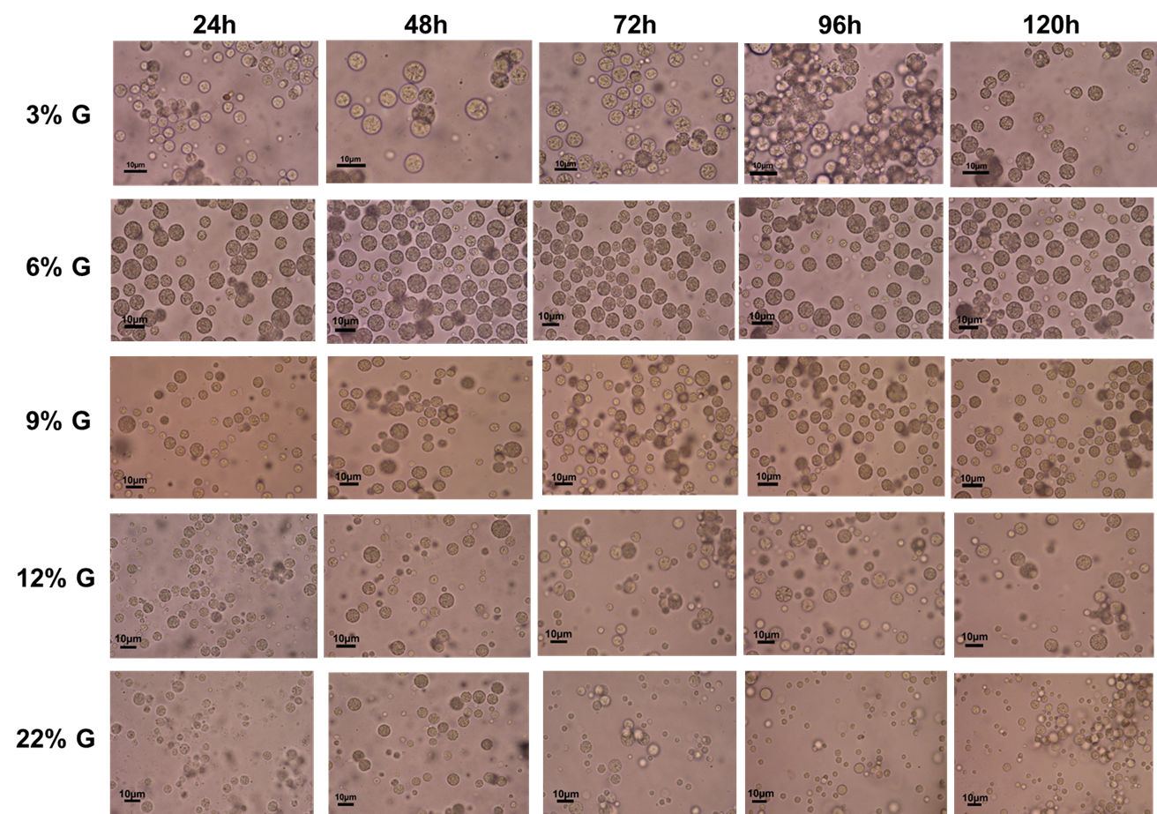

Figure 2: Cell morphology of S. mangrovei PQ6 at different initial glucose concentrations under light microscope (x 400 magnification). G: glucose.

Cultivation at initial glucose concentration of 9% resulted in the highest DCW and squalene production. The maximum DCW and squalene production were 35.5 ± 0.1 g/L and 1.1 ± 0.1 g/L (Figure 1). Therefore, the optimal initial glucose concentration for batch fermentation was 9%.
Effect of nitrogen sources on cell growth and squalene accumulation in bath fermentation
Nitrogen is a natural occurring element that is essential for cell growth and accumulation of secondary compounds under fermentation conditions of microorganism. Generally, nitrogen sources used are inorganic nitrogen sources such as ammonia and nitrate as well as simple organic nitrogen sources such as urea and monosodium glutamate. The commonly used complex nitrogen sources include peptone, yeast extract and tryptone [3]. For Thraustochytrids, it was reported that the best nitrogen source for cell growth and squalene production of Aurantiochytrium sp. in conical flask was mixture of yeast extract and monosodium glutamate [3]. Thus, in this study, we evaluated the effect of different nitrogen sources (yeast extract – Y and yeast extract combined with monosodium glutamate – YM) on the growth and squalene accumulation of S. mangrovei PQ6 in fermentation at 30 L fermentor. The results were shown in Figure 3.
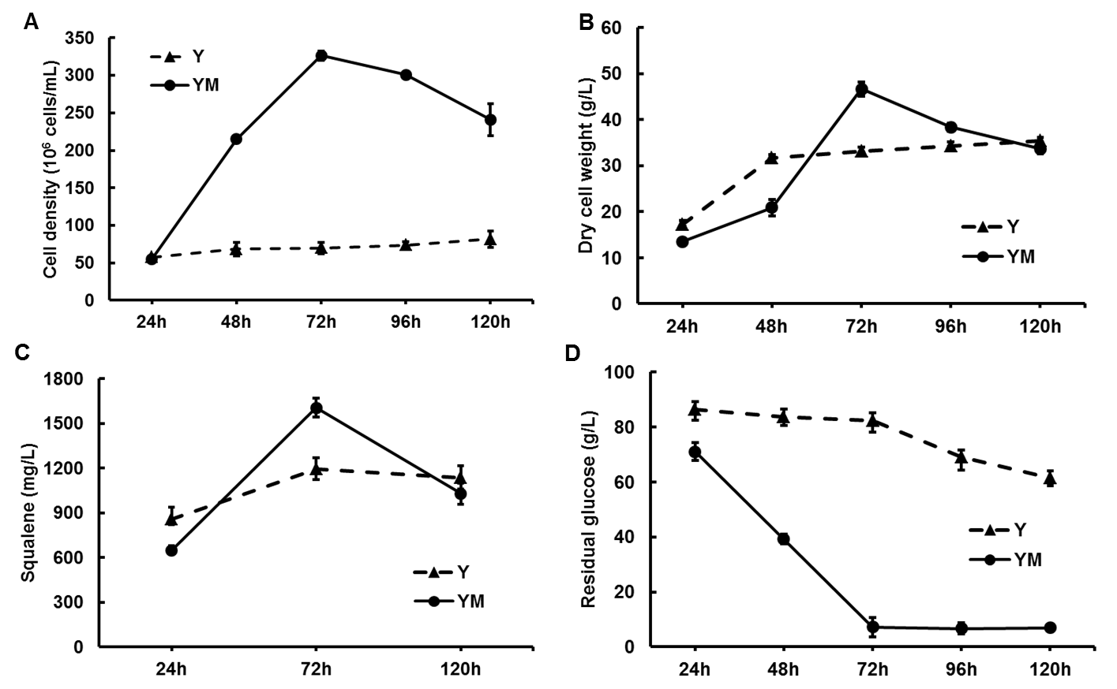

Figure 3: Effect nitrogen source on cell density (A), dry cell weight (B), squalene production (C) and residual glucose (D) in S. mangrovei PQ6. Y: yeast extract; YM: yeast extract and monosodium glutamate.

As shown in Figure 3A-C, the cell density, DCW and squalene yield of S. mangrovei PQ6 were significantly influenced by nitrogen sources. Cell density, DCW and squalene yield were low in the medium containing Y. In contract, when YM was used as a nitrogen source, high levels of cell density, DCW and squalene production were obtained with maximal value of 3.3 x 10⁸ cells/mL, 46.7 g/L and 1.6 g/L at 72 hours fermentation, respectively. After that, DCW and squalene production decreased slightly and showed no significant difference between medium containing Y and YM.
According to Fan et al. [5], growth rate of algae has closely relationship to glucose consumption. The growth rate of algae reduces in the glucose-deficient culture medium and vice-versa. In present study, we analyzed the glucose consumption in culture medium containing YM and showed that glucose concentration decreased remarkably while the cells were fast reproducing during 0-72h. The residual glucose in culture medium was 71 g/L at 24 hours, 39 g/L at 48h and 7.1 g/L at 72 hours (Figure 3D). After 72 hours of fermentation, glucose concentration in medium began to exhaust, resulting in decrease in cell growth and squalene production. On the contrary, glucose concentration in medium containing Y decreased slightly. After 120 hours of fermentation, residual glucose was 61.4 g/L and growth rate reached the maximum value with DCW of 35.5 mg/L.
Our results suggested that YM was able to enhance glucose consumption and transformation into biomass in fermentation process by S. mangrovei PQ6. Squalene productivity of the system was induced by increasing the biomass.
Effect of fed-batch fermentation on cell growth and squalene accumulation
The fed-batch culture with the intermittent addition of glucose and without the removal of fermentation broth is one of the most common methods for the production of second compounds as ethanol, squalene etc in the industry [4, 15]. Pora et al. [15] reported that squalene content in genus thraustochytrid increased 5-10 times in fed-batch fermentation with adding glucose up to 22% compared to in bath fermentation. We, therefore, studied the trend of cell growth, glucose consumption and squalene formation of S. mangrovei PQ6 in fed-batch cultivation with adding glucose up to 22%. The switching time for the fed-batch fermentation was determined from the result of the batch fermentation. Based on the data presented in Figure 3, glucose concentration decreased rapidly after 24 hours and was depleted at 72 hours. So, the feeding of glucose was decided to start at 48 hours of fermentation cycle.
High glucose concentration appeared to affect cell size (Figure 2), however, there was no change observed at various stages in fed-batch fermentation (Figure 4). Cell density and DCW were found to increase rapidly during 108 hours of fermentation. They started to decrease only after achieving a maximum concentration of 3.9 ± 0.1 × 10⁸ cells/mL and 326.0 ± 0.4 g/L at 108 hours of fed-batch fermentation, respectively (Figure 5 A and B). These results consistent with analysis result of residual glucose content that started to deplete at 108 hours of fermentation (Figure 5D). The squalene production reduced at 84 hours, although the cell density and DCW still increased. The highest squalene production achieved 4.8 ± 0.3 g/L at 84 hours (Figure 5C). In comparison with the batch culture, production of squalene increased 2-3 times in fed-batch fermentation.
We suggested that the fed-batch fermentation was a better fermentation system than the bath fermentation. The fed-batch fermentation supported higher cell growth as well as squalene production.

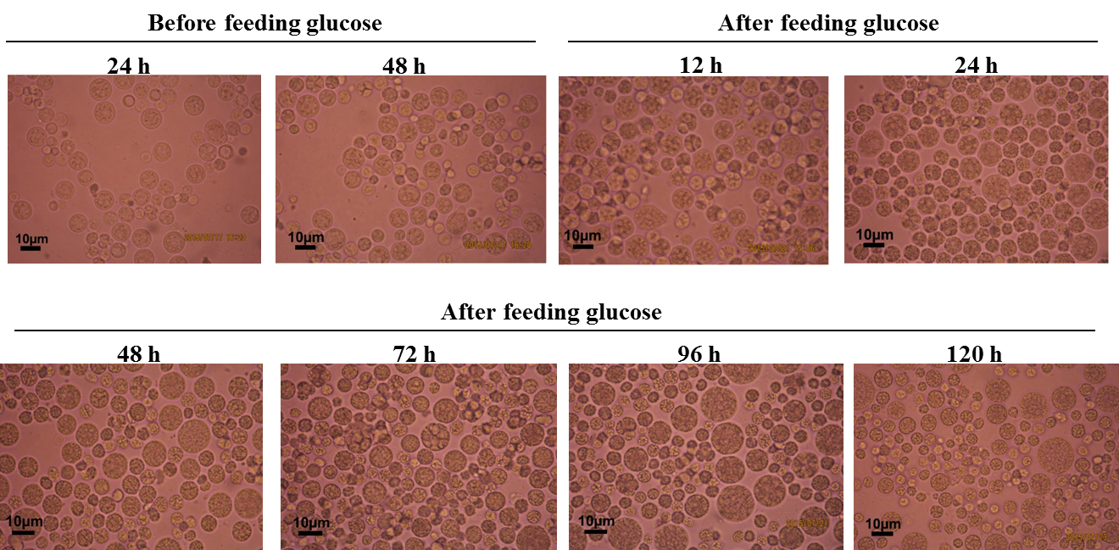

Figure 4: Cell morphology of S. mangrovei PQ6 during fed-batch fermentation under light microscope (x 400 magnification).
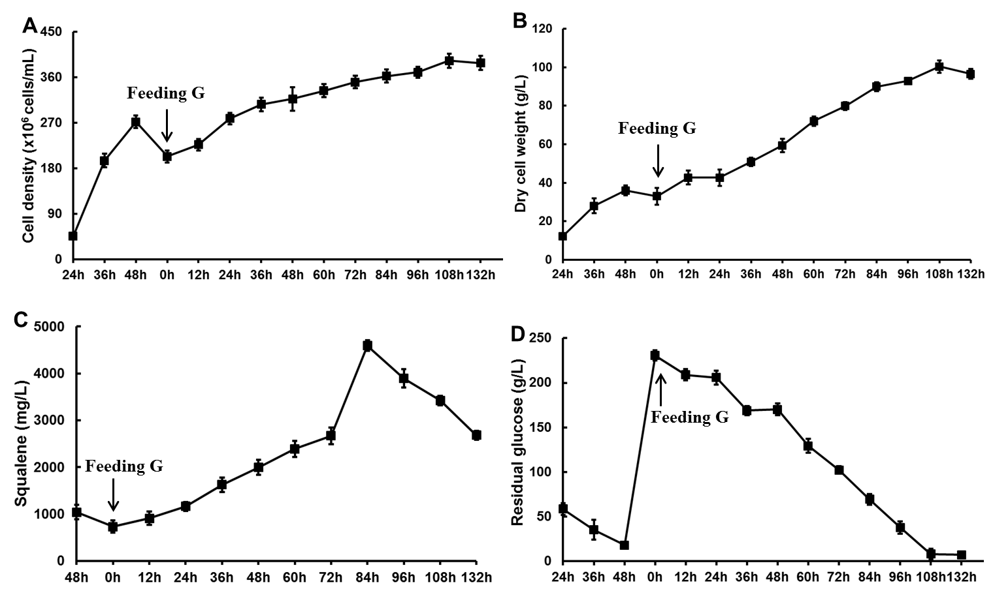

Figure 5: Cell density (A), dry cell weight (B), squalene production (C) and residual glucose (D) profile of the fed-batch fermentation. G: glucose.
Effect of vitamin mixture on cell growth and squalene accumulation in fed-batch fermentation
Vitamins B₁, B₆ and B₁₂ each fill many different roles that support human body’s metabolism and help it produce essential substances, such as neurotransmitters and red blood cells. Recently, these vitamins have been successfully applied to induce the accumulation of squalene in several species as Auranchytrium sp. and Schizochytrium sp. Pora et al. [15] found that vitamin B₁₂ plays role as a cofactor of some of the key enzymes involved in squalene biosynthesis, vitamin B₁ increases the intracellular amount of squalene precursors by stimulating the leucine degradation pathway, and vitamin B₆ prevents squalene degradation by modifying the action of cytochromes. Here, we investigated the effect of addition of vitamin B₁, B₆ and B₁₂ mixture on cell growth and squalene production in fed-batch fermentation.

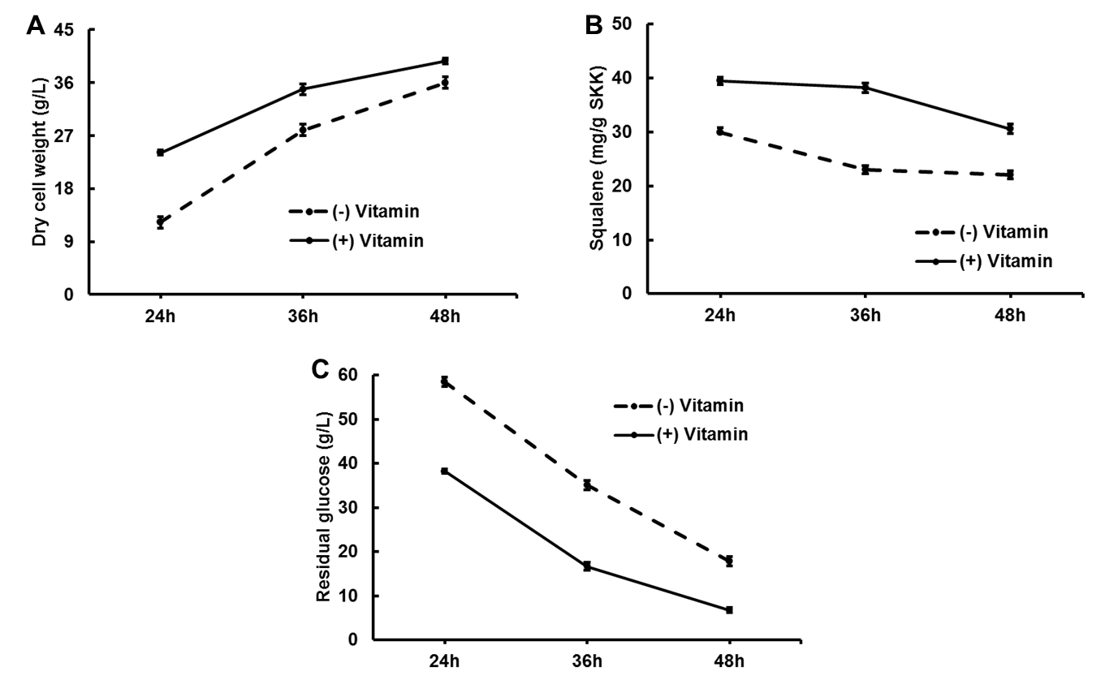

Figure 6: Effect of vitamin B1, B2 and B12 mixture on dry cell weight (A), squalene production (B) and residual glucose (C) during batch fermentation.

In order to conduct the fed-batch fermentation condition in medium adding vitamins, batch fermentation with and without vitamin addition were carried out to study the trend of cell growth, squalene production and glucose consumption. The biomass of S. mangrovei PQ6 in medium containing vitamins mixture increased rapidly during 48 hours while the squalene production is shown to remain almost constant for the 36 hours (Figure 6A and 6B). The concentration of glucose was then decreased and depleted at 48 hours during the fermentation, coinciding with an increase in the production of cell and squalene (Figure 6C). Compared with cells growing in medium without vitamins, the biomass, squalene production and glucose consumption were higher in medium with vitamins. This is due to adding vitamins enhanced the cells and consuming the glucose in the system to increase the growth of cell and the production of squalene. Based on Figure 7, we determined that the optimum switching time from bath to fed-batch fermentation in medium with vitamin mixture was at 36 hours.
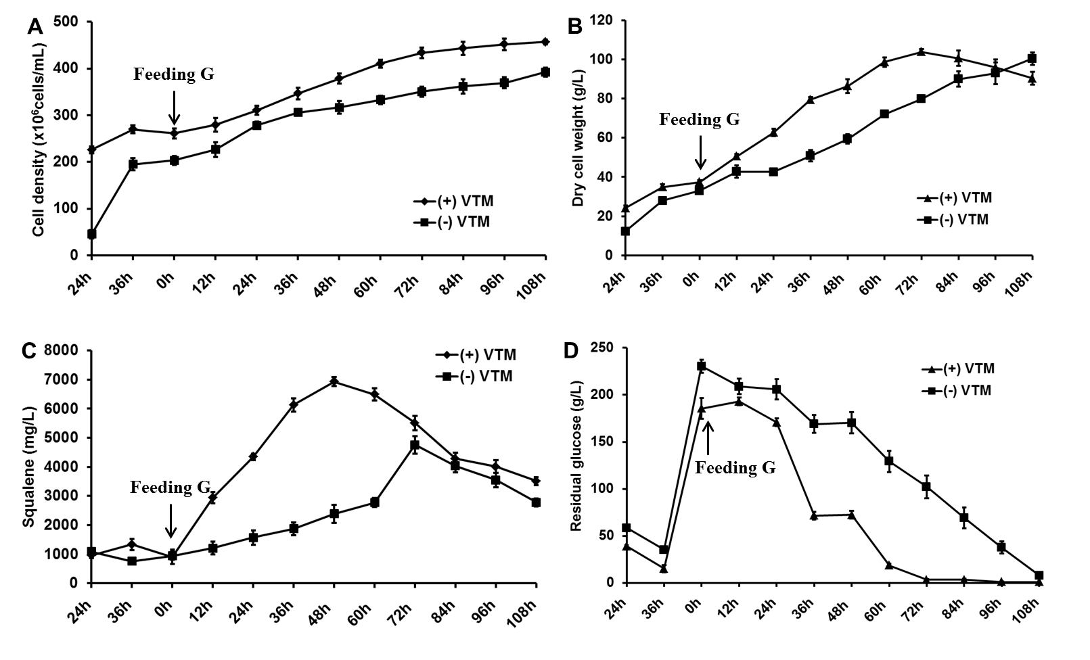

Figure 7: Effect of vitamin B₁, B₂ and B₁₂ mixture on cell density (A), dry cell weight (B), squalene production (C) and residual glucose (D) during fed-batch fermentation. G: glucose; VTM: vitamin mixture.

The change in cell density, biomass, squalene production and glucose concentration at different culture stages when fed-batch fermentation in medium with and without vitamin mixture was shown in Figure 7. The result showed that cell density and DCW in medium with vitamins was higher than in medium without vitamins. After 72 hours of the cultivation, biomass content reached maximum value of 103.8 ± 0.3 g/L and glucose consumption content also achieved maximum value, over 98% of glucose content has been consumed.
In addition to increasing growth rate, vitamin mixture was also confirmed to be capable of stimulating squalene biosynthesis in strain PQ6 (Figure 7C). After adding glucose concentration to 22%, squalene production increased strongly from 0 to 48 hours and then reduced. At 48 hours, squalene production was achieved 6.9 ± 0.1 g/L. The values were increased in 2-3 times higher than by fed-batch culture in medium without vitamins and in 4-6 times compared to batch culture. This trend is in agreement with the report of Pora et al. [15]. Therefore, we harvested the cells of PQ6 strain after 48 hours of fed-batch fermentation in order to collect squalene-rich biomass.
In comparison with Schizochytrium strains in report of Pora et al. [15], squalene production of S. mangrovei PQ6 much higher in their study. Production of squalene in our study reached 6.9 ± 0.1 g/L, while this value in Schizochytrium sp. ATCC 20888 and Auranriochytrium sp. ATCC PRA 276 achieved 3.7 and 1.7 g/L, respectively. In addition, production of squalene in our study also was the highest among published S. mangrovei which was twenty and forty times compared with the result obtained in the article of Pora et al. [15] in the presence of vitamin mixture (with a maximum squalene content of 4 mg/g biomass) and Yue and Jiang [19] in the presence of methyl jasmonate (with a maximum squalene content of 1.2 mg/g biomass), respectively.
CONCLUSION
This study was aimed at demonstrating that heterotrophic marine microalgal species of S. mangrovei PQ6 is a promising candidate for commercial squalene production. Fed-batch fermentation and vitamin B₁, B₆ and B₁₂ mixture are target factors to improve the production of squalene in S. mangrovei PQ6.
Acknowledgements: This research is funded by Vietnam National Foundation for Science and Technology Development (NAFOSTED) under grant number 106.03-2012.92 for Assoc./Prof. Dr. Dang Diem Hong and by Vietnam Academic of Science and Technology (VAST) under grant number VAST.ĐLT.11/14-15 for Dr. Hoang Thi Minh Hien. We are grateful for the use of the facilities of National Key Laboratory, Institute of Biotechnology, VAST.
REFRENCES
- Anh H. T. L., Ha N. C., Thom L. T., Hong D. D., 2016. Optimization of culture conditions and squalene enrichment from heterotrophic microalga Schizochytrium mangrovei PQ6 for squalene production. Res. J. Biotechnol., 11: 81-91.
- Bhattacharjee P., Shukla V. B., Singhal R. S., Kulkarni P. R., 2001. Studies on fermentative production of squalene. World J. Microbiol. Biotechnol., 17: 811–816.
- Chen G., Fan K. W., Lu F. P., Li Q., Aki T., Chen F., Jiang Y., 2010. Optimization of nitrogen source for enhanced production of squalene from thraustochytrid Aurantiochytrium sp. N. Biotechnol., 27: 382- 389.
- Cheng N. G., Hasan M., Kumoro A. C., Ling C. F., Tham M., 2009. Production of Ethanol by Fed-Batch Fermentation. Pertanika J. Sci. & Technol., 17: 399-408.
- Fan K. W, Aki T, Chen F., 2010. Enhanced production of squalene in the thraustochytrid Aurantiochytrium mangrovei by medium optimization and treatment with terbinafine. World J. Microbiol. Biotechnol., 26: 1303-1309.
- Fan K. W., Chen F., 2007. Production of high-value products by the marine microalgae thraustochytrids. In: Yang, ST (ed) Bioprocessing for value-added products from renewable resources: new technologies and applications. Elsevier. Science., 293-323.
- Hoang M. H., Ha N. C., Thom L. T., Tam L. T., Anh H. T., Thu N. T., Hong D. D., 2014. Extraction of squalene as value-added product from the residual biomass of Schizochytrium mangrovei PQ6 during biodiesel producing process. J. Biosci. Bioeng., 118: 632-639.
- Hong D. D., Anh H. T. L., Thu N. T. H., 2011. Study on biological characteristics of heterotrophic marine microalgae – Schizochytrium mangrovei PQ6 isolated from Phu Quoc island from Phu Quoc island, Kien Giang province, Vietnam. J. Phycol., 47: 944-954.
- Jiang Y., Fan K. W., Wong R. T. Y., 2004. Fatty acids composition and squalene content of the marine microalga Schizochytrium mangrovei. J. Agric. Food. Chem., 52: 1196-1200.
- Kelly G. S., 1999. Squalene and its potential clinical ues. Alternative medicine review 4(1): 29-36.
- Li Q., Chen G. Q., Fan K. W., Lu F. P., Aki T., Jiang Y., 2009. Screening and characterization of squalene-producing thraustochytrids from Hong Kong mangroves. J. Agric. Food Chem., 57: 4267-4272.
- Miller G. L., 1959. Use of dinitrosalicylic acid reagent for determination of reducing sugar. Anal. Chem., 31: 426-428.
- Nakazawa A., Matsura H., Kose R., Kato S., Honda D., Inouye I., Kaya K., Watanabe MM., 2012. Optimization of culture of the thraustochytrid Aurantiochytrium sp. strain 18W-13a for squalene production. Biores. Technol., 109: 287-291.
- Okada S., Devarenne T. P., Chappell J., 2000. Molecular characterization of squalene synthase from the green microalga Botrycoccus braunii, race B. Arch. Biochem. Biophys., 373: 307-317.
- Pora B., Qian Y., Caulier B., Comini S., Looten P., Segueilha L., 2014. Method for the preparation and extraction of squalene from microalgae. Patent US20140088201.
- Qu L., Ren L. J., Sun G. N., Ji X. J., Nie Z. K., Huang H., 2013. Batch, fed-batch and repeated fed-batch fermentation processes of the marine thraustochytrid Schizochytrium sp. for producing docosahexaenoic acid. Bioprocess. Biosyst. Eng., 36: 1905- 1912.
- Smith T. J., 2000. Squalene: potential chemopreventive agent. Expert. Opin. Investig. Drugs., 9: 1841–1848.
- Spanova M., Daum G., 2011. Squalene – biochemistry, molecular biology, process biotechnology, and applications. Eur. J. Lipid Sci. Technol., 113: 1299-1320.
- Yue C. J., Jiang Y., 2009. Impact of methyl jasmonate on squalene biosynthesis in microalga Schizochytrium mangrovei. Process Biochemistry., 44: 923-927.

TỐI ƯU HÓA CÁC ĐIỀU KIỆN NUÔI CẤY LÊN MEN CHO SẢN XUẤT SQUALENE TỪ VI TẢO BIỂN DỊ DƯỠNG SCHIZOCHYTRIUM MANGROVEI PQ6
Nguyễn Cẩm Hà^{1,2}, Hoàng Thị Minh Hiền¹*, Lê Thị Thơm¹, Hoàng Thị Hương Quỳnh¹, Đặng Diễm Hồng¹*
¹Viện Công nghệ Sinh học, Viện Hàn Lâm Khoa học và Công nghệ Việt Nam, 18 Hoàng Quốc Việt, Cầu Giấy, Hà Nội, Việt Nam
²Học Viện Khoa học và Công nghệ, Viện Hàn Lâm Khoa học và Công nghệ Việt Nam, 18 Hoàng Quốc Việt, Cầu Giấy, Hà Nội, Việt Nam
*hoangminhhien@yahoo.com, ddhong60vn@yahoo.com

TÓM TẮT
Squalene có tác dụng ngăn ngừa ung thư và làm giảm nguy cơ mắc bệnh tim mạch vành. Squalene cũng là một chất chống oxy hóa mạnh được sử dụng rộng rãi trong các ngành công nghiệp thực phẩm và mỹ phẩm. Các nghiên cứu gần đây tập trung vào tìm kiếm nguồn sản xuất squalene từ vi sinh vật. Trong bài báo này, chúng tôi nghiên cứu điều kiện nuôi cấy Schizochytrium mangrovei PQ6 cho sản xuất squalene cao ở hệ thống bình lên men 30 lít. Các yếu tố ảnh hưởng đến sản lượng squalene được thử nghiệm là glucose, nguồn nitơ, hỗn hợp vitamin, kiểu lên men theo mẻ hoặc lên men theo mẻ có bổ sung cơ chất. Kết quả cho thấy điều kiện tối ưu cho sản xuất squalene cao nhất là lên men theo mẻ có bổ sung cơ chất với nguồn nitơ là 1,2% cao nấm men và 6,4% mì chính và 0,4% hỗn hợp vitamin B1,6 và 12. Trong đó, nồng độ cơ chất, glucose, được bổ sung vào môi trường đạt tới 22% ở 36h lên men. Hệu suất squalene đạt cao nhất là 6,9 ± 0,1 g/L ở thời điểm 48h lên men theo mẻ có bổ sung cơ chất. Giá trị này cao gấp 2-3 lần so với lên men theo mẻ có bổ sung cơ chất nhưng không bổ sung hỗn hợp vitamin và cao gấp 4-6 lần khi lên men theo mẻ thông thường. Kết quả thu được là một bước đột phá cho sự phát triển nguồn squalene thay thế từ vi tảo biển dị dưỡng Schizochytrium mangrovei PQ6 để làm thực phẩm chức năng tăng cường sức khỏe con người.

